**Project Design Phase-II**

**Data Flow Diagram & User Stories**

|  |  |
| --- | --- |
| Date | 30 June 2025 |
| Team ID | LTVIP2025TMID30150 |
| Project Name | Streamlining Ticket Assignment for Efficient Project Management |
| Maximum Marks | 4 Marks |

**Data Flow Diagrams:**

A Data Flow Diagram (DFD) represents how data flows within the ServiceNow ticketing system. It helps visualize how data such as ticket details, user roles, and assignment logic move across modules and interact with automated assignment processes.

**Example:** [**(Simplified)**](https://developer.ibm.com/patterns/visualize-unstructured-text/)

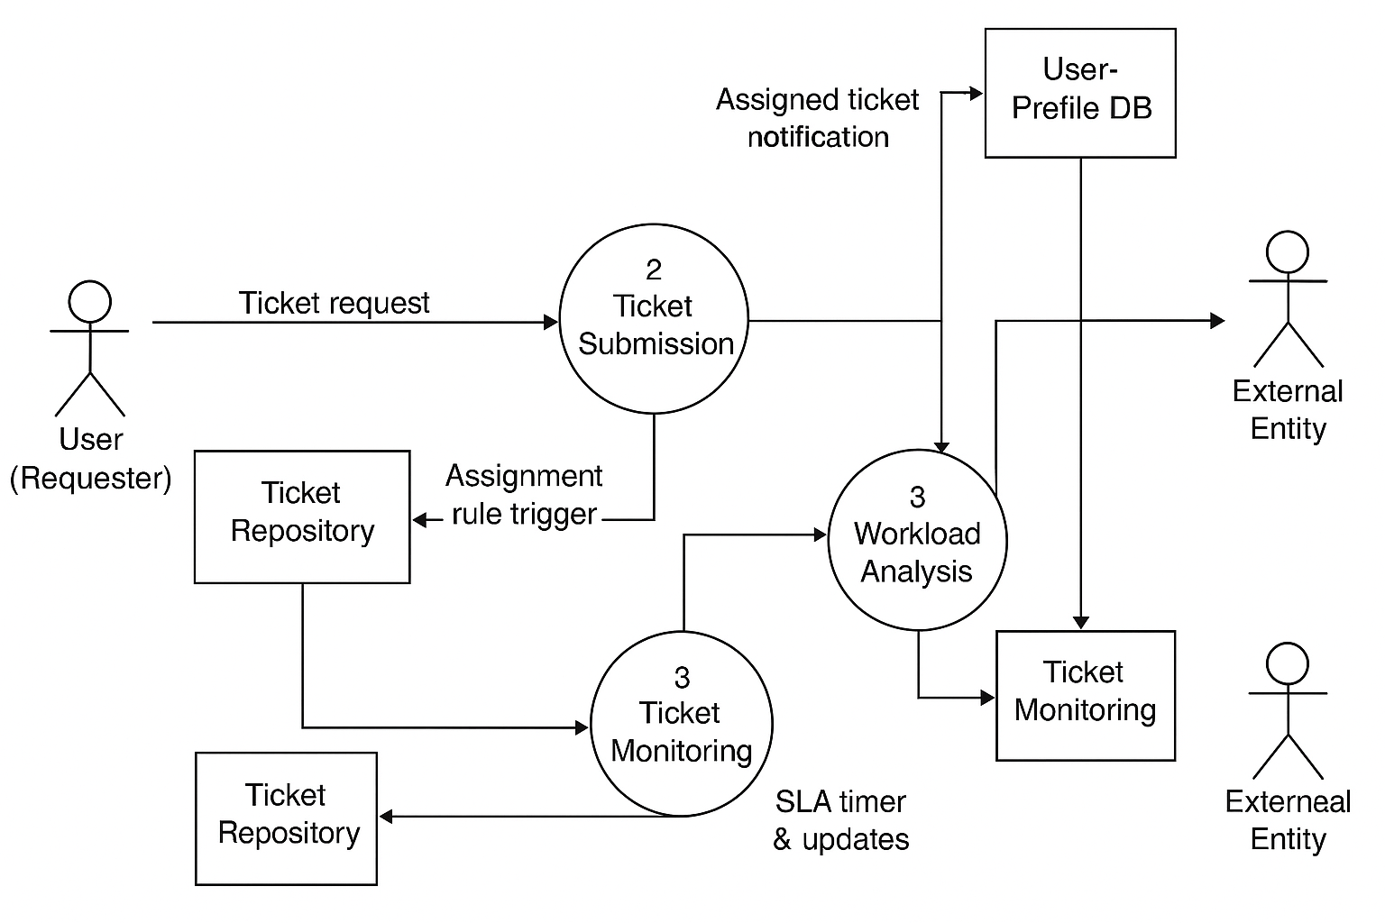

**User Stories**

Use the template below to define the product backlog and organize the sprint schedule for efficient ServiceNow automation.

| **Sprint** | **Functional Requirement (Epic)** | **User Story Number** | **User Story / Task** | **Story Points** | **Priority** | **Team Members** |
| --- | --- | --- | --- | --- | --- | --- |
| Sprint-1 | Ticket Intake & Classification | USN-1 | As a user, I can submit a ticket with details like category, priority, and description. | 2 | High |  |
| Sprint-1 | Assignment Rule Setup | USN-2 | As an admin, I can configure rule-based assignment using ServiceNow Assignment Rules. | 3 | High |  |
| Sprint-1 | User Role Mapping | USN-3 | |  | | --- | |  |  |  | | --- | | As a manager, I can map users to teams and roles for better ticket distribution. | | 2 | Medium |  |
| Sprint-2 | Workload Monitoring | USN-4 | As a manager, I can view real-time workload dashboards to balance team assignments. | 3 | High |  |
| Sprint-2 | |  | | --- | |  |  |  | | --- | | SLA Tracking | | USN-5 | |  | | --- | |  |  |  | | --- | | As a system, I can track the aging of tickets and raise alerts on SLA breaches. | | 4 | High |  |
| Sprint-2 | Auto Re-assignment Logic | USN-6 | As a system, I can reassign tickets automatically if the assignee is overloaded. | 5 | Medium |  |
| Sprint-3 | Machine Learning Integration | USN-7 | |  | | --- | |  |  |  | | --- | | As a developer, I can implement ML-based auto-assignment based on past ticket data. | | 5 | Medium |  |
| Sprint-3 | System Testing & Deployment | USN-8 | As a QA engineer, I can test the rule logic and deploy it on the ServiceNow instance. | 3 | High |  |